EXPERIMENT 2

ROLL NUMBER:240701262 NAME: KEVINBHARATH.P

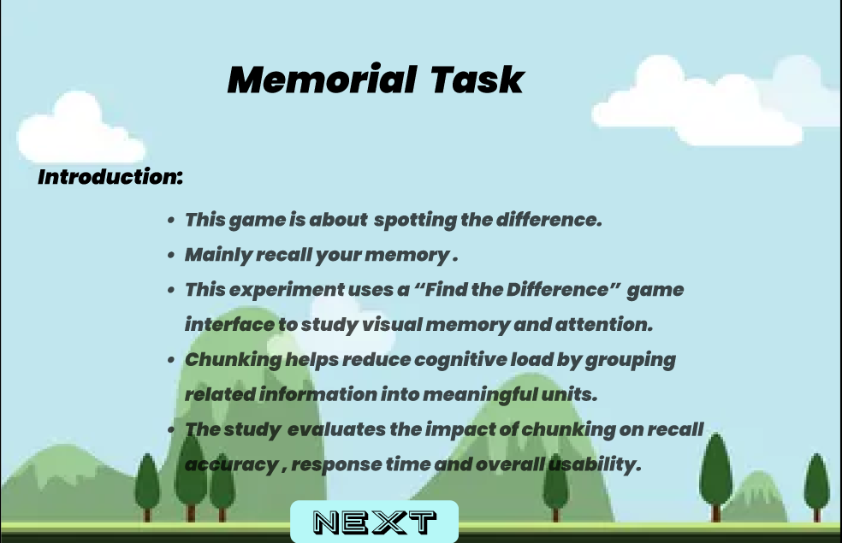

Objective

To investigate how chunking (grouping related information into meaningful units) affects:



Visual memory recall accuracy

Response time

Overall task performance

Background

Visual memory and attention are essential cognitive processes used to recognize and recall visual information. The “Find the Difference” task is commonly used to measure these abilities.

Chunking is a cognitive strategy that reduces mental load by organizing information into structured groups. This experiment evaluates whether applying chunking improves performance in visual comparison tasks.
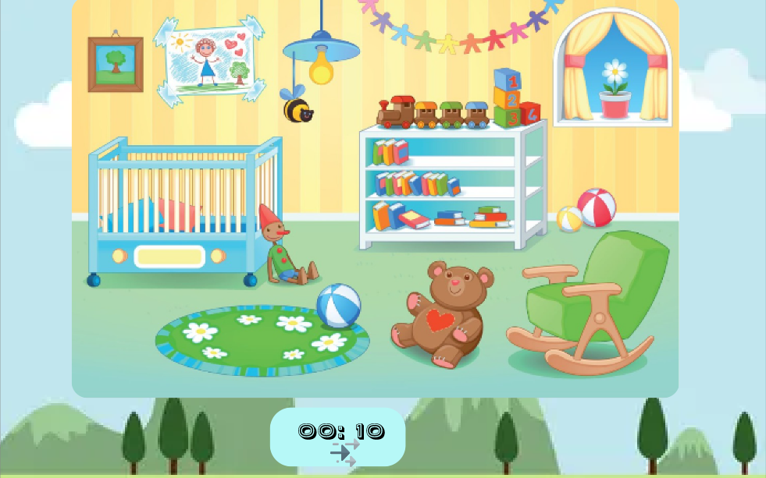

Methodology
Participants

Individuals asked to complete a visual comparison task.

Task Design

Participants observe two similar images (e.g., a nursery scene).

They identify and click on the differences between the images.

Time taken and accuracy are recorded.

Some participants may be guided to use chunking (e.g., scan by sections: top, middle, bottom; left to right).

Variables


Independent Variable:
Use of chunking strategy (with chunking vs. without chunking)

Dependent Variables:

Number of correctly identified differences

Response time

Error rate

Controlled Variables:

Same images

Same number of differences

Same viewing time conditions

Procedure

Participants read instructions.

They observe two images carefully.

They identify differences by clicking on changed elements.

The system records:

Time taken

Accuracy

Missed differences

Expected Outcome

It is expected that:

Participants using chunking will identify differences more accurately.

Response times may improve due to structured scanning.

Cognitive load will be reduced.

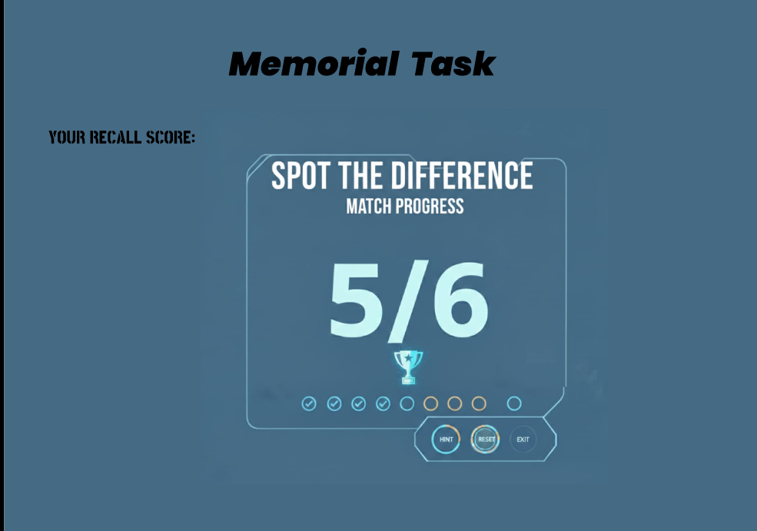

Conclusion

This experiment helps evaluate how cognitive strategies like chunking enhance visual memory, attention, and usability in interactive tasks.

PROTOTYPE LINK:

https://www.figma.com/proto/XoW9CVmWxC7spY5R2mT387/Memorial-Task?node-id=7-10&starting-point-node-id=7%3A10&t=KocXjpI7RDEr9nW0-1

